Help Page for Welcome to My Family Health Portrait

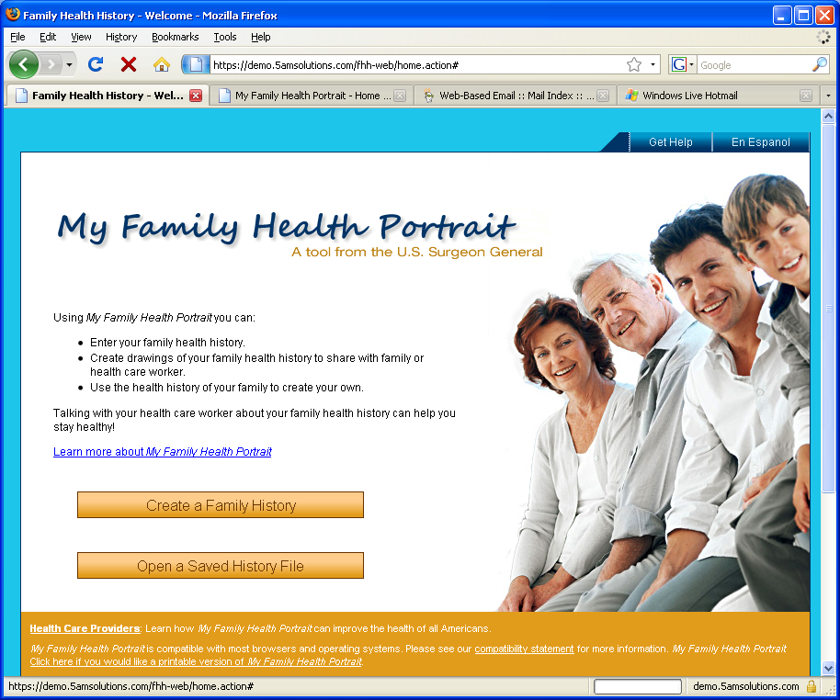

The Welcome to My Family Health Portrait page is a start page where you can:
- Create your family health history
Or
- Look at a saved history file that you or a family member created

To start your family history, click on Create a Family History. This will bring you to a page where you can enter in your health information.

If you have a family history file that was created using this website, you may click on the Open a Saved History File button on the Welcome to My Family Health Portrait page.

Please note: if you created a family history using this site before January 2009, you will need to create a new version by clicking on the Create a Family History button.

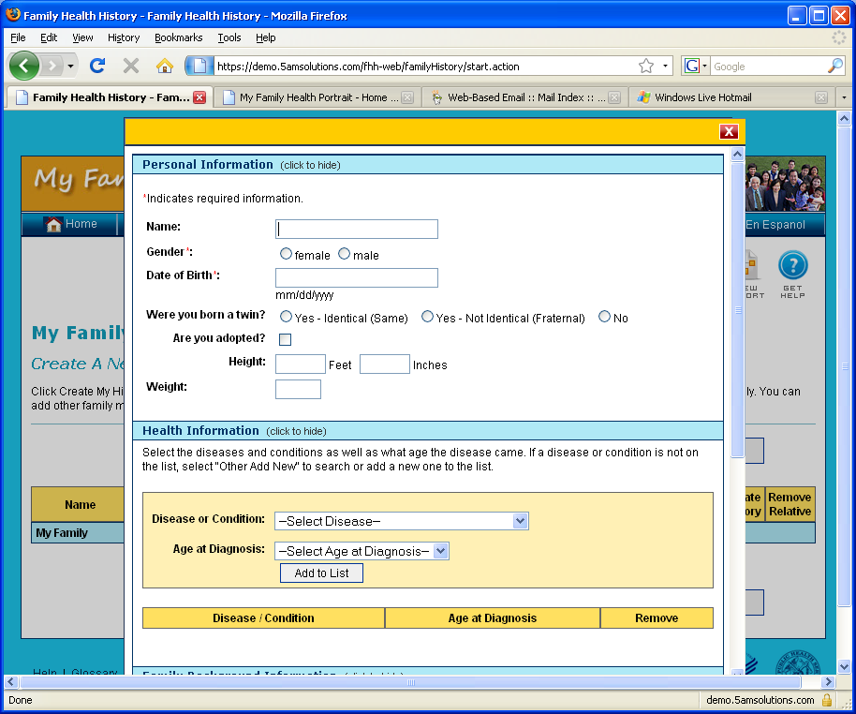

Enter Personal Information
When creating your personal information you will be asked to:
- Enter your personal information such as name, gender, date of birth, twin status, adopted status, height and weight.
- Enter your health information. This includes:
  - Selecting the disease or condition you may have by clicking on the drop-down selection box next to the “Disease or Condition” label
  - If you select a disease or condition that has the words ‘more options…” next to it, you will be asked to give more information by clicking on the drop-down box next to the “Please Specify” label
  - Select the age of onset from the ranges that are offered after clicking on the drop-down selection box next to “Age at Diagnosis”
  - You can add more diseases or conditions after adding one to the list. You can also click on the ‘Remove’ link if the information doesn’t appear correct
- Enter you family background. This includes:
  - Selecting whether your parents are related to each other in any way other than being married
  - Selecting the race and ethnic background for a family member. Please note that you can select more than one option within this list. You will also be able to provide more specific race information
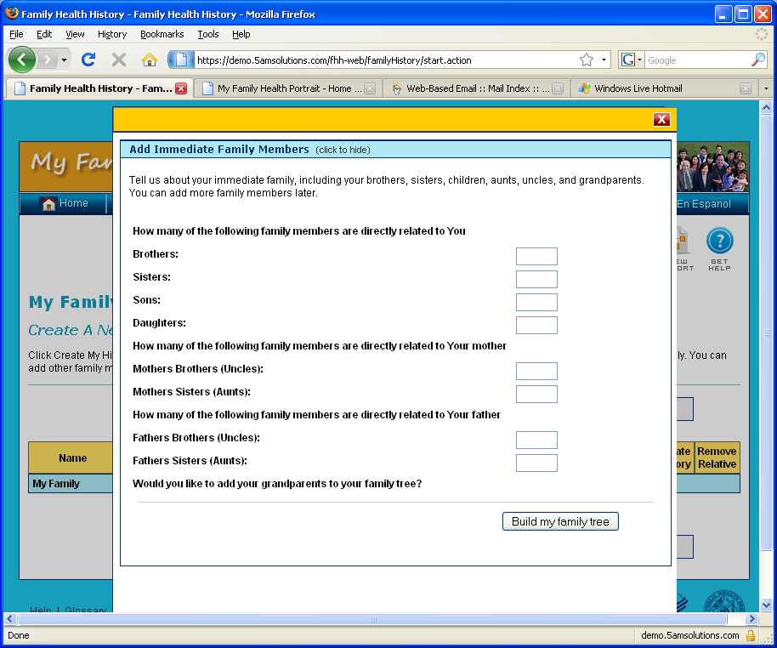

Add Immediate Family Information
- Create a Family Tree. This includes:
  - Typing in the number of brothers, sisters, daughters, and sons you have
  - Typing in the number of brothers and sisters that your mother has
  - Typing in the number of brothers and sisters that your father has
  - Showing whether or not you would like to add grandparents to your family tree
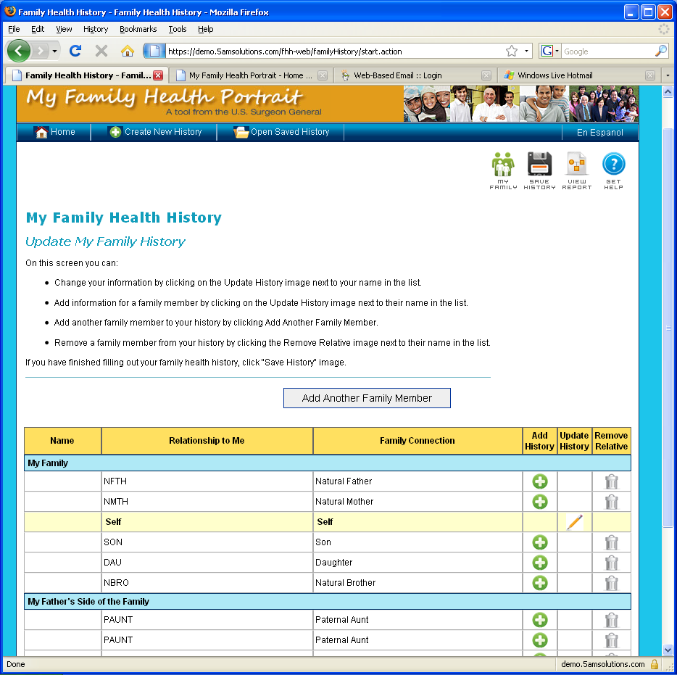

Update My Family History
After adding immediate family information, you can:
- Check over the relatives in the family member table by doing the following:
  - add health history for each family member by clicking on the symbol in the Add History column
  - update health information for you or anyone by clicking on the symbol in the update history column
  - remove a family member by clicking on the symbol in the remove relative column
- Add additional relatives by clicking the ‘Add Another Family Member’ button
- Import a previously developed family health history by clicking the ‘Import Family Health History’ button (Please note that this will over-write any existing work that you done in creating your family health history)
- Save your family history to your computer by clicking on ‘Save Family History’
On all pages including this page, you can also:
- Save your family history to your computer by clicking ‘Save Family History’
- View a drawing of your family tree or a chart of your family health history by clicking ‘View Report’
- Return to the screen showing your family by clicking ‘My Family’
- Return to the screen showing your family by clicking the ‘Home’
- Start a new history by clicking on ‘Create New History’.
- Bring in a previously developed history by clicking on the ‘Open Saved History’.

